

Department of Computer Engineering
SIES GRADUATE SCHOOL OF TECHNOLOGY
NERUL, NAVI MUMBAI 400706
ACADEMIC YEAR
2024 - 2025

Report on
“Cloud-Based Bus Pass System”

Submitted By

Vinita Narayanan | 122A1123
Janhvi Dhale | 223A1129
Karthika Thevar | 223A1136

Under the guidance of
Prof. Ujwala Ravale
Assistant Professor
Department of Computer Engineering

ACKNOWLEDGEMENT

We would like to express our sincere gratitude to all those who contributed to the successful completion of our project, Cloud-Based Bus Pass System.
We are especially thankful to our professor, Prof. Ujwala Ravale, for her invaluable guidance, continuous support and encouragement throughout the course of this project. Her insights and constructive feedback greatly enhanced the quality of our work.
We would also like to extend our heartfelt thanks to our Principal, Dr. K. Lakshmisudha, and Head of the Department, Dr. Aparna Bannore, for providing us with the necessary resources and a conducive environment to carry out our project work.
Our sincere appreciation goes to all team members for their collective effort, dedication and collaborative spirit. The exchange of ideas and mutual support played a significant role in the successful execution of this project.

From the team members:
Vinita Narayanan 122A1123
Janhvi Dhale 223A1129
Karthika Thevar 223A1136

INDEX

S no | Content | Page No
1 | Aim | 4
2 | Abstract | 4
3 | Problem Statement | 4
4 | Problem Solution | 5
5 | Cloud Services Used | 5
6 | Output | 6
7 | Conclusion | 10

- Aim
The aim of this project is to develop a Cloud-Based Bus Pass and Booking System that streamlines student transportation by providing a smart, digital alternative to traditional processes. The platform enables students to apply for bus passes, reserve seats, track buses in real time, and communicate transport-related concerns through a student forum.
This system minimizes manual intervention, reduces queue times, and improves communication between students and administrators. Hosted on a cloud platform, the system ensures high availability, scalability, and ease of access from any internet-enabled device. It ultimately aims to offer a modern, centralized solution to enhance the daily commute experience for students.
- Abstract
Many educational institutions still rely on outdated manual methods to manage bus pass issuance and seat bookings. These methods are often inefficient and prone to errors. The Cloud-Based Bus Pass and Booking System seeks to digitize this process through a web application built using HTML for the frontend, Flask (Python) for backend, and a MySQL cloud database. Students can register, apply for bus passes, reserve or book emergency seats, and track buses in real-time bus tracking feature powered by Leaflet.js and OpenStreetMap allows users to monitor live bus locations on the map, enhancing safety and reducing wait times.. The platform also includes a student discussion forum for transport-related communication. Deployed on a cloud platform like AWS, the system ensures accessibility, improved uptime, and seamless scalability to meet growing demand. This modern approach aims to create an efficient and transparent student transport management system.
- Problem Definition
Traditional bus pass and seat booking systems suffer from several issues:
i. Paper-based and manual processes often cause confusion, overbooking, and delays.
ii. Lack of real-time bus tracking results in uncertainty and inefficiency.
iii. No provision for last-minute or emergency seat booking.
iv. Absence of a communication platform for students to raise issues or seek assistance from the transport team.
These limitations affect both students and administrative staff, leading to dissatisfaction and increased workload.

- Proposed solution
The proposed Cloud-Based Bus Pass System addresses these challenges by offering the following key features:
- User Login: Secure student login system for accessing bus services.
- Online Bus Pass Application: Students can apply for passes and view bus routes online.
- Seat Booking System: Students can select buses and reserve seats based on real-time availability.
- Live Bus Tracking :Integrated using Leaflet.js and OpenStreetMap tiles, the system allows students to view the real-time location of buses on a digital map.
- Emergency Booking Module: Provides an option to book seats in emergency situations without prior scheduling.
- Student Forum: A dedicated section for students to post queries, share feedback, or report transport issues, promoting better communication.
The system is designed with scalability in mind, making it easy to integrate with multiple institutions and expand its features in the future.

- Cloud Services Used
The project utilizes various cloud-based tools and services to improve performance, scalability, and accessibility:
i. Leaflet.js + OpenStreetMap – Used for real-time bus tracking and map rendering on the dashboard using the following tile layer:
L.tileLayer('https://{s}.tile.openstreetmap.org/{z}/{x}/{y}.png').addTo(map);
This setup allows a free and open-source alternative to Google Maps, enabling dynamic and customizable map views.
ii. Cloud Hosting Platform (e.g. AWS) – Hosts the Flask-based backend and HTML frontend on the internet for 24/7 access.
iii. Cloud MySQL Database (e.g. AWS RDS) – Stores all application data including user details, bookings, routes, and forum interactions in a secure and scalable cloud environment.
These services ensure data consistency, improve application uptime, and make the platform accessible across locations without the need for local infrastructure.

- Output
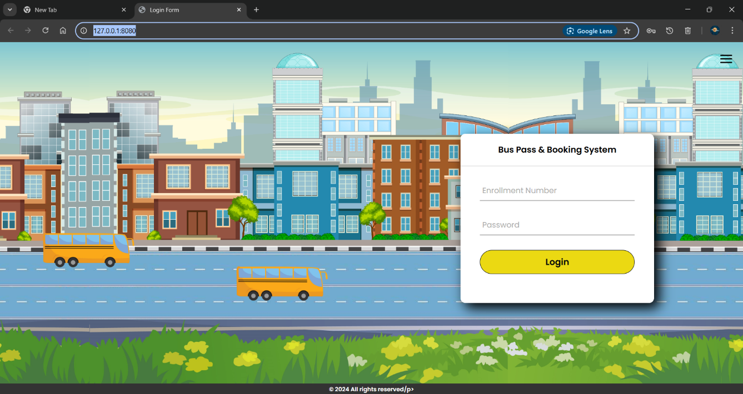
Figure 1: Login

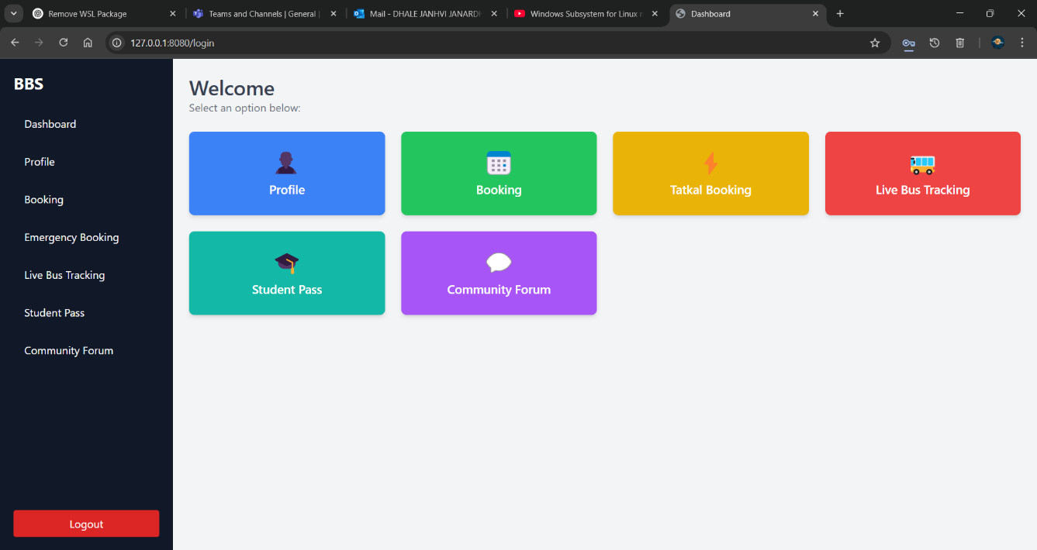
Figure 2: Dashboard

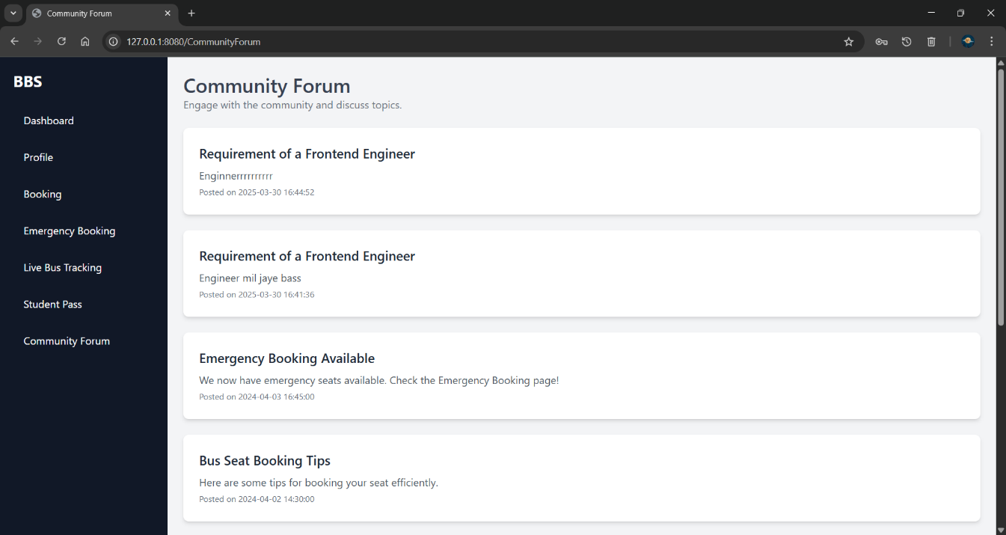
Figure 3: Community Forum

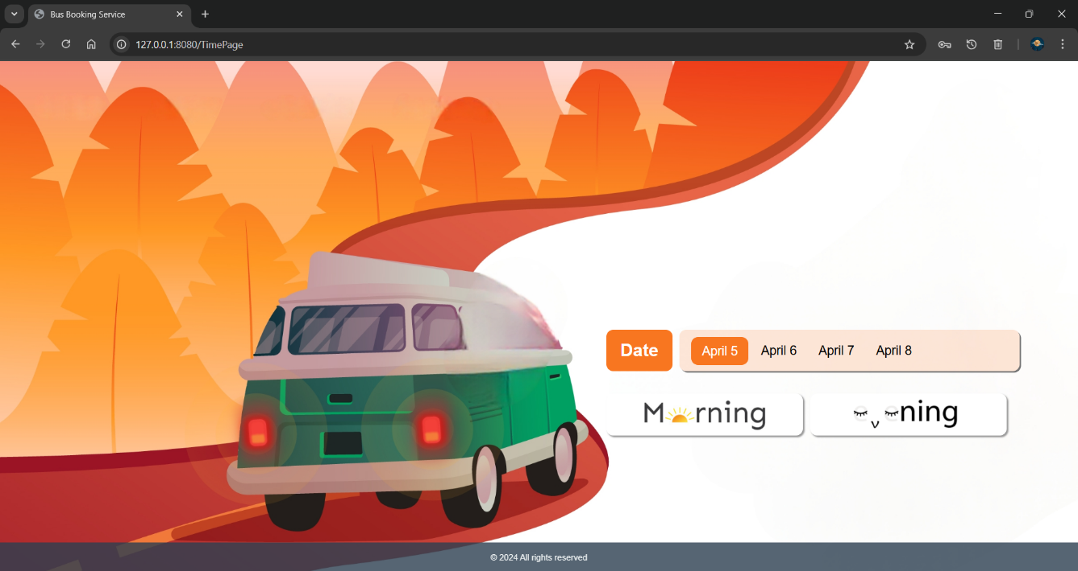
Figure 4: Booking Ticket

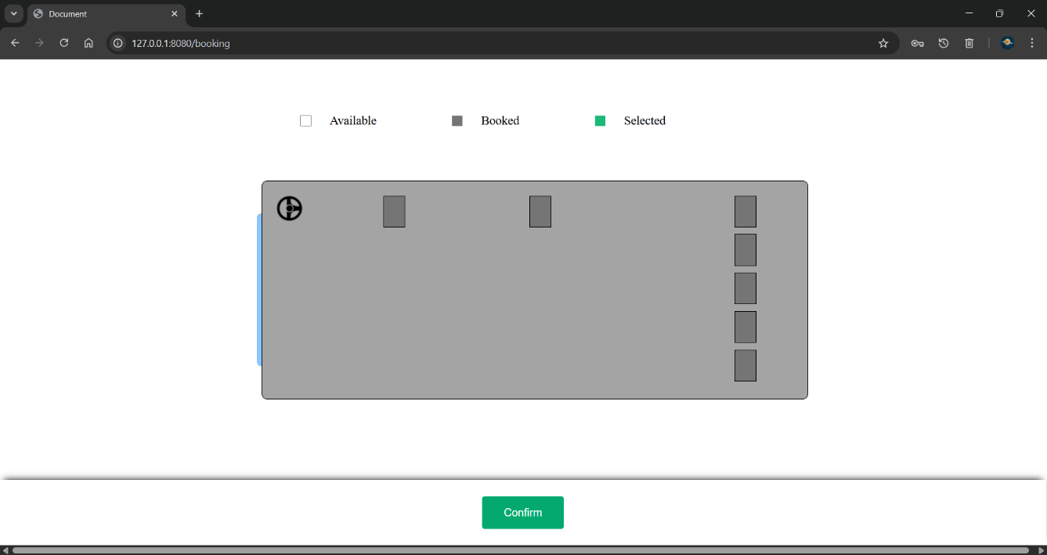
Figure 5: Seat booking

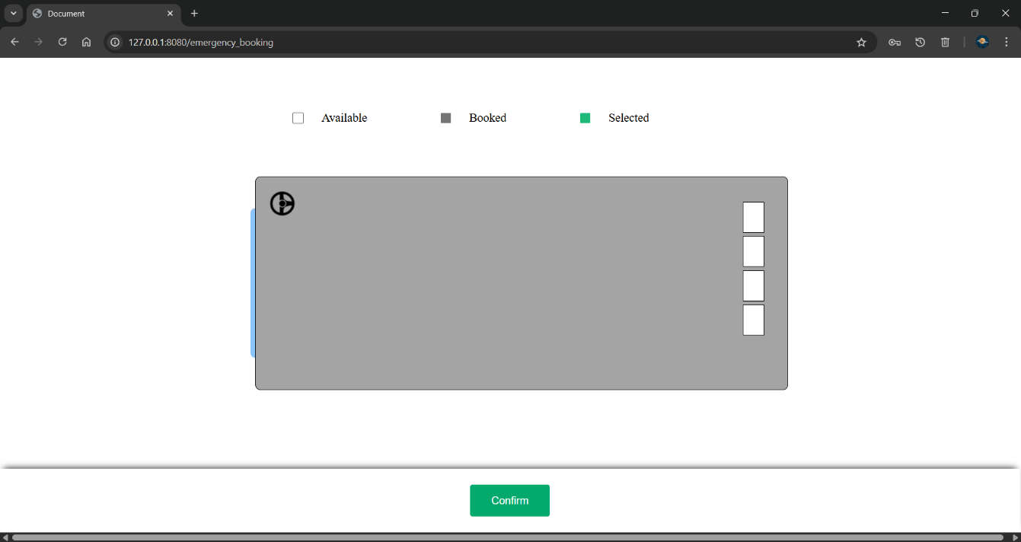
Figure 6: Tatkal Seat

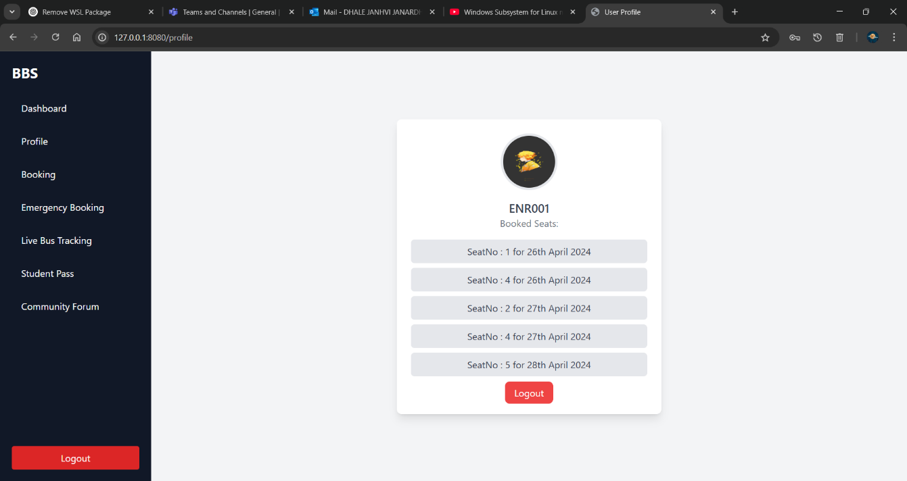
Figure 7: Profile

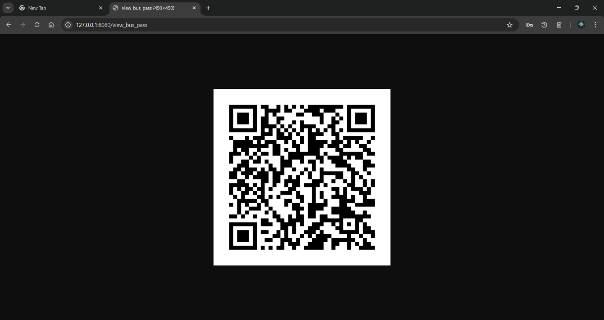
Figure 8: Pass

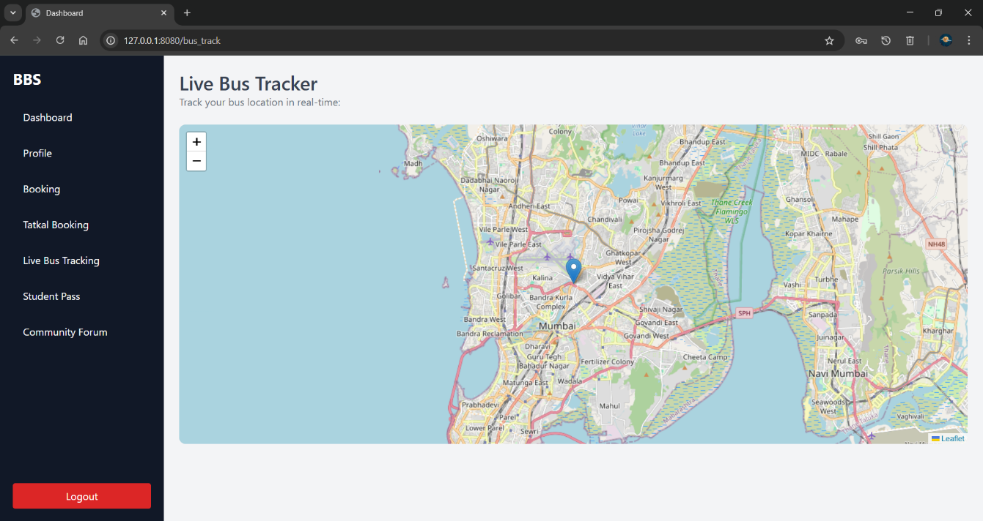
Figure 9: Live Tracking

- Conclusion
The Cloud-Based Bus Pass System offers a modern, user-friendly, and effective solution for managing transportation services in educational institutions. By shifting traditional manual processes to a digital platform, the system makes seat booking quicker, more organized, and easily accessible for students. This not only saves time but also minimizes the hassles of long queues and paperwork.
The inclusion of real-time bus tracking significantly enhances student safety by allowing users and administrators to monitor the exact location of buses. This feature adds an extra layer of reliability and transparency to the transportation process. Additionally, the dedicated student forum encourages active communication between students and the transport department, ensuring that concerns or suggestions can be addressed efficiently.
Built using cloud technologies, the system ensures high availability, secure data storage, and easy maintenance, while also allowing for scalability to support a growing number of users. Its clean interface and structured backend make it adaptable for different institutions like schools, colleges, or private transport services.
In summary, this project contributes to creating smarter, safer, and more efficient campuses. It demonstrates how technology can be used to improve everyday student life, making travel more organized, informed, and seamless.

